1. **Problem 8 on page 131 of Jorgensen's Software Testing.    You must include a decision table as part of your submission.    See the syllabus for a link to the online version of this book.**

"The retirement pension salary of a Michigan public school teacher is a percentage of the average of their last 3 years of teaching normally, the number of years of teaching service is the percentage multiplier.  To encourage senior teachers to retire early, the Michigan legislature enacted the following incentive in May of 2010:

Teachers must apply for the incentive before June 11, 2010.  Teachers who are currently eligible to retire (age >= 63 years) shall have a multiplier of 1.6% on their salary up to, and including, $90,000, and 1.5% on compensation in excess of $90,000.   Teacher who meet the 80 total years of age plus years of teaching shall have a multiplier of 1.55% on their salary up to, and including, $90,000 and 1.5% on compensation in excess of $90,000.

Make a decision table to describe the retirement pension policy; be sure to consider the retirement eligibility criteria carefully.  What are the compensation multiplier for a person who is currently 64 with 20 years of teaching whose salary is $95,000?" +

**Author: Veena Somashekarappa**

**Summary**: Assumptions/known facts:

* Encouraging senior teachers to retire early
* Percentage of avg age of their last 3 years of teaching.
* Normally, the number of years of teaching service is the percentage multiplier.
* Currently eligible teachers (>=63) shall have a multiplier of 1.6% on their salary up to, including 90k, and 1.5% on remaining.

**Question**.

What are the compensation multipliers for a person > 64 age with 20years of teaching whose salary is 95k?

**Answer**.

1.6% of 90k (a portion of 95k) and 1.5% on 5k (balance of 95k base salary)

Further, if this person was 80 years old then

1.6% of 90k (a portion of 95k) and 1.55% of 5k (balance of 95k base salary).

|  |  |  |  |  |  |
| --- | --- | --- | --- | --- | --- |
| **Inputs** | **Values** | **Combinations** | | | |
| Teacher Type | A,B | A | B |  |  |
| >=63y($90000),1.6% | Y,N | Y | N |  |  |
| >=63y and 80y ,$5000,1.5% | Y,N | Y | Y |  |  |
| 80YEARS, 90000,1.55% | Y,N | N | Y |  |  |
|  |  |  |  |  |  |
| Outputs |  |  |  |  |  |
| 1.60% |  | Y |  |  |  |
| 1.50% |  | Y | Y |  |  |
| 1.55% |  |  | Y |  |  |

1. Create a complete set of test cases for the [microwave oven state diagram](https://sit.instructure.com/courses/40685/modules/items/857845) (follow the link for the diagram).   You may assume that the only possible combinations of states and events are included in the state diagram.  Be sure to cover all possibilities.  Include your state table and test cases in your answer. How many tests are required to fully test the solution?

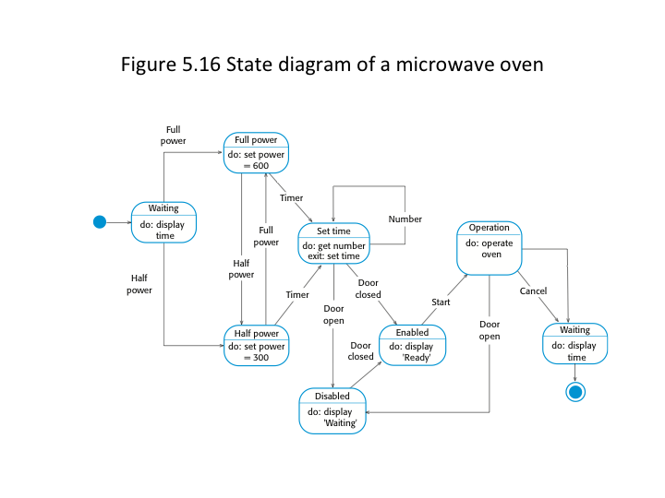

**Summary:** As a tester, we need to assume values or inputs to some states while writing test cases.

Since microwave oven diagram states are easily recognizable and imagine the states, test case writing is a simple task. Here, the test cases are written with very high level information where as in real life, assumptions, presets, configuration/calibration settings are written prior to each test case.

|  |  |  |  |  |  |  |  |  |
| --- | --- | --- | --- | --- | --- | --- | --- | --- |
| **States\Commands** | **Half Power** | **Full Power** | **Timer** | **Door Open** | **Door Closed** | **Start** | **Cancel** | **Timeout** |
| **Waiting** | Waiting | Waiting |  |  |  |  |  | Waiting |
| **Set Full Power** |  | Set Full Power | Set Time |  |  |  |  |  |
| **Set Time** | Set Time | Set Time | Set Time | Set Time | Set time |  |  |  |
| **Set Half Power** | Set Half Power |  | Set Time |  |  |  |  |  |
| **Disabled** |  |  |  | Waiting | Waiting |  |  |  |
| **Enabled** |  |  |  |  | Ready | Ready |  |  |
| **Operation** |  |  |  | Waiting |  | Start | Waiting |  |

|  |  |
| --- | --- |
| **Total Possible Test Cases** | **7*8 =56** |

|  |  |  |  |  |
| --- | --- | --- | --- | --- |
| **Test Case ID** | **Current State** | **Event** | **Output** | **Next State** |
| T-200 | Waiting | Set Full Power | Power=600 | Set Time |
| T-201 | Waiting | Set Half Power | Power=300 | Set Time |
| T-202 | Full Power | Set Half Power | Half Power | Set Time |
| T-203 | Full Power | Timer | Get Number | Set Time |
| T-204 | Half Power | Set Full Power | Full Power | Set Time |
| T-205 | Half Power | Timer | Get Number | Set Time |
| T-206 | Set Time | Number | Get Number | Set Time |
| T-207 | Set Time | Door Open | Display Waiting | Waiting |
| T-208 | Set Time | Door Closed | Display Ready | Enabled |
| T-209 | Disabled | Door Closed | Display Ready | Enabled |
| T-210 | Enabled | Start | operate Oven | Operation |
| T-211 | Operation | Door Open | Display Waiting | Disabled |
| T-212 | Operation | Cancel | Display time | Waiting |
| T-213 | Operation | Timeout | Display time | Waiting |

|  |  |
| --- | --- |
| **Test Case ID** | **Test Case Description** |
| T-200 | Set the current state to "Waiting". Set the full power to 600. Verify that the next state is Set time. |
| T-201 | Set the current state to "Waiting". Set the full power to 300. Verify that the next state is Set time. |
| T-202 | Set the current state to Full Power. Change the power to 300. Verify that the next state is Set time |
| T-203 | Set the current state to Full Power. Verify that that display timer number is displayed to set time |
| T-204 | Set the current state to Half power. Change to full power to 600 and verify that number is displayed to set time |
| T-205 | Set the current state to Half power. Verify that the timer is displayed to set time |
| T-206 | Verify that timer is displayed after the set time state is complete. |
| T-207 | Verify that the Waiting is displayed when time is set and door is open |
| T-208 | Verify that the Enabled is displayed when time is set and door is closed |
| T-209 | Set the current state to Disabled. Verify that the Enabled is displayed when time is set and door is closed. Display Ready is shown. |
| T-210 | Set the current state to Enabled. Verify that Operation is active when the door is closed. |
| T-211 | Set the current state to Operation. Verify that Waiting is displayed when door is open |
| T-212 | Set the current state to Operation .Verify that the time is displayed when cancel operation is completed. Waiting is displayed. |
| T-213 | Set the current state to Operation .Verify that the time is displayed when timeout operation is completed. Waiting is displayed. |

**Lessons Learnt/Experience:**

It was hard to understand what the real salary amount is for retirees. It was confusing why 80 years is brought in the picture for calculation.

Once, I read through the paragraph many times and written down all the calculations, it was a very simple mathematical analysis.

**Honor pledge**

I pledge on my honor that I have not given or received any unauthorized assistance on this assignment/examination. I further pledge that I have not copied any material from a book, article, the Internet or any other source except where I have expressly cited the source.”